TRENCH WARFARE .. at Andrewzgamez ( Google it )
The Allies verses the Central Powers
The Objective : To have more attacking ( charging ) infantry IN your opponent’s trench after the completion of 10 turns(*) than they have in yours’.
turns(*) … see ‘ Turns ’ , later
If your opponent’s charging infantry are all eliminated before the completion of 10 turns , and you still have at least one infantry piece in their trench , you win .
Pre-amble : The scene , somewhere in France , during the later stages of the First World War . The artillery barrage that customarily precedes an infantry charge has just finished . Your opponent is left with 6 men in their trench and 3 workable artillery pieces to defend its line . The barrage has created a number of fox-holes ( pot-holes ) , and a break in the barbed-wire . It is now time to ‘ go over the top ’ as part of ‘ the big push ’ . My wish is that players of this game grasp a better understanding of what now seems an absurd tactic , and appreciate how lucky they are not to have been a part of it .
1 . Requirements : I would suggest adjusting the settings of your printer so that each player’s board may be printed on 2 A4 size pages . Of course , this would have to be done twice . Alternatively , print an A4 size page board ( 1 for each player ) , and then perhaps enlarge it to A3 .
1B . One die ( here on called ‘dice’ )
1C . 10 turn markers .
1D . Infantry and artillery pieces/tokens . Andrew strongly recommends using plastic figures of a game based on WW1 or WW2 , between the Allies and the Central Powers or Axis , but tokens of any sort are pretty much okay . Alternatively , print the pieces supplied in the ‘ T.W. Figures ’ file , then perhaps glue onto cardboard , and cut .
The figures : ( counters)
24 German charging infantry ( or 24 tokens of a certain color - say ,black. )
24 British/American charging infantry ( represented by 24 tokens of a different color - say , green or brown . )
6 Central Powers ( say , Austrian ) trench defending infantry ( tokens of a different color again - say , yellow .)
6 French defending infantry ( perhaps blue tokens .)
3 Central Power artillery pieces ( say , red .)
3 French artillery pieces ( say , purple. )
2 . The set-up :
2A . Place one A3 size printed Trench Warfare game board in front of each of the opposing 2 players , thus :

C.P. = Central Power player sits here :
A.P. = Allied Player
sits here :
C.P. trench
defending
infantry
C.P.
charging
infantry start position
C.P .
artillery
A.P. trench
defending
infantry
A.P .
artillery
A.P.
charging
infantry start position
Each player places their 24 charging infantry ( figures or tokens ) to the right of the thin red line in front of them . Each piece occupies 1 space . Do not place on hexagons with the arrows . They just serve as reminders to work down the board .
2B . The Central Powers player then places their 6 defending infantry ( again , either figures or tokens ) in the trench on the board in front of their opponent .
2C . The allied player then does the same – vice-versa .
2D . The Central Powers player then places the 3 artillery pieces ( figures or counters ) behind the trench that they are defending .
2E . The Allied player does like-wise .
In other words , the defending infantry and artillery are almost together , on the left side of the opposing player’s board . Thus , the pieces representing your charging infantry , your defending infantry and your artillery pieces should all be pretty much in a line on your right side . The stage is now set for play to begin ….
3 . ‘ Turns ’ : There is a maximum of 10 turns in the game . Each turn comprises the following 12 steps :
3A . The Central Powers’ player moves(@) their charging infantry .
Moves(@) ; See ‘ Movement ’ , later .
3B . The Central Powers’ charging infantry fire. See ‘ Firing ’ later .
3C . The Allied player moves their charging infantry , Moves(@)
3D . The Allied charging infantry fire – Again , see Firing later .
3E . The ALLIED player moves their trench defending infantry , if desired .
3F . The trench defending infantry of the ALLIED player fire . Although the Central Powers’ charging infantry will be out of range – at least for the first turn .
3G . The ALLIED player moves their artillery , if desired .
3H . The artillery of the ALLIED player fire .
3I . The Central Powers player moves their trench defending infantry , if desired .
3J . The trench defending infantry of the Central Powers player fire ( ..but there will not be any first turn , – out of range )
3K . The Central Powers player move their artillery , should they so desire .
3L . The artillery of the Central Powers player fire .
… there we go , the 12 steps . The artillery only have a possible shot on the first few turns , in practice . They may be used for possible cover+ though , later in the game .
cover+ ; See ‘ Cover ’ , later .
4 . Movement : - NOTE : movement is never a requirement .
4A . Whether you are attacking or defending , ALWAYS MOVE pieces in descending order - from north to south , or top to bottom . The pieces themselves may move upward , straight forward , downward or not at all .
4B . If you first move a piece from , say , half-way down the board , all pieces above the figure’s beginning position CANNOT then be moved !
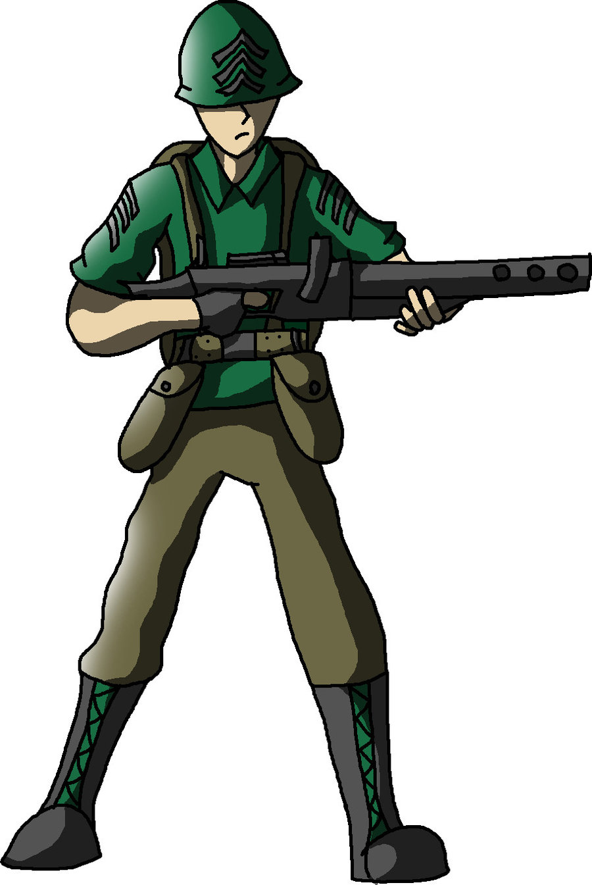
Z
Y
X
Look at Illustration B. If a player moves figure Y , to any of the spaces it can ( as indicated ) , then the player CANNOT move X , because X is in a higher position higher up the line than Y . It does not matter where Y finished the move . It is the position the figures were , in relation to each other , before the movement phase began , that determines the order that the pieces can be moved . In the example above , if Y was moved before X , X cannot then move this turn .The next movable piece would be Z , even if piece Y was moved to hexagon P , because position is determined at the beginning of the turn .
P
Illustration B. ( IL B. )
4C . Each piece may move once only per turn .
4D . You can only move pieces that begin their move from a position either lower than , OR on the same level as , the previously moved piece – and their position in relation to one another is determined before the movement phase began .
4E . This ‘ moving of pieces in descending order ’ , can be annoying at times . It may prevent a player moving a certain piece as they may have wished . All part of the game , and it is the same for both players . The rule exists to lessen the problem of knowing whether a figure had moved already that turn or not . This is sometimes a problem in games of a similar nature .
4F . You cannot move into the partial hexagons on the board’s edges .
4G . No two of your pieces can occupy the same space . You cannot even pass through a space occupied by ANY piece .
4H . One of your infantry pieces may occupy the same space as one of your opponent’s infantry , but then the situation of ‘ hand-to-hand combat ’ # arises . Such a situation is only ever temporary .
‘ hand-to-hand combat ’# ; See later in this rule booklet .
4I . No infantry figure may ever occupy the same space as an artillery piece .
4J . Movement within the trench is restricted to one space . This is due to debris , bodies and general conditions of the trench in the aftermath of an artillery barrage .
4K . Movement out of a trench is also limited to one space , due to the difficulty and danger of such an act .NOTE – 4L .
4L . However ..( Re 4K.) , you may move 2 spaces and land in the trench .
4M . Each artillery piece may move only one space per turn . They must remain behind the trench .
4N . Charging infantry on open ground (~) may move up to 2 spaces , HOWEVER ..
- The water-way ( the blue line ) does NOT stop pieces from advancing 2 spaces .
** You must stop in a fox-hole . You cannot simply pass through it . You remain safe from rifle fire whilst in the hole . If you are playing with plastic figures , I would suggest placing the pieces on their side to more strongly indicate this . You may move 2 spaces on leaving a fox-hole . You cannot fire from within a fox-hole .
***You must stop at spaces with ‘ barbed-wire ’ . You cannot just pass through in one move . No protection is afforded by this obstacle . You may move 2 spaces on departing such an obstacle . You CAN NOT move onto wire ( 1 space even ) AND fire .
Open ground (~) – All areas other than that in the trench .
5 . Firing : - Note : Firing is not compulsory either .
5A . Artillery : Artillery can never be destroyed in this game . These units fire ONLY horizontally across the board . Units in the trench , and to the left of the water-way on open ground ( 4N . above ), are safe from artillery blasts . Look first at the upper-most artillery piece . Work from the upper-most artillery unit down . Ask ‘ Is there a perfectly straight line across , with an opponent’s charging infantry piece in sight ? AND .. Is the piece to the right of the water-way ? ( the blue line ) If the answer to both these questions is ‘ Yes ’ , then the artillery piece may fire . So …
@ Roll the dice . A roll of ‘ 6 ’ is an automatic miss – applies ONLY to artillery , not infantry . On rolls of between 1 and 5 , count from the first space to the right of the blue water-way , up to the number shown on the dice . A low roll may well miss . Should there be a hit , the FIRST ONLY charging infantry piece reached is a casualty , and is
removed from the game . So , for example : See IL C. ( below )
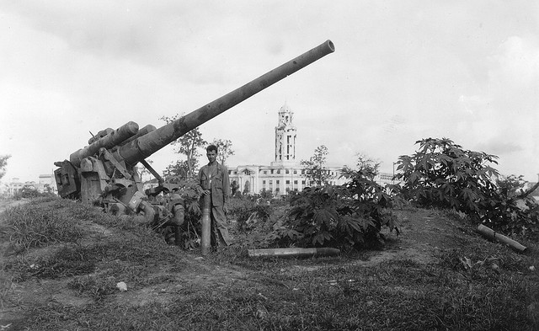
6 is
a
miss !
5
4
2
3
1
Water-way
Trench
An artillery piece has a line to 2 charging infantrymen , both to the right of the
IL C.
water-way . The dice is rolled . The number displayed is a ‘4 ’ . So , count up to 4 spaces right , from the hexagon adjacent the water-way . Both figures are within the ‘4’ , but only the first hit is lost .
5B . Defending Trench Infantry : Pieces in the trench can never be hit by their own artillery . As for targets , see 5E .
5C . Charging Infantry : Charging infantry may move up to 2 spaces on open ground . However , doing so means that they CAN NOT fire . Charging Infantry may move 1 space on open ground AND fire . A charging infantry figure , either moved 1 space or not at all , may fire . There must be a straight line of hexes to the target , same as defending infantry . You must declare your targeted piece , then roll the dice .Those that have reached the trench have the same degree of protection as the defenders .
5D . Infantry fire in a straight line in the direction of any one of the 6 sides of the hexagon . You can never fire through your own pieces ( applies also to those on the same side in the trench ) nor those of your opponent. For defending infantry : The first figure of your opponent in a line of fire is the one hit. See IL D.(below) . For Charging Infantry : You MUST roll the exact number to eliminate a figure in the trench .
5E . Begin firing from the upper-most infantry piece , and work down . For each piece , ask ‘ Do I have a target ? Do I have a straight line of hexes to an opponent , is that opponent in open-ground , and is the opponent within 6 hexes ? You can never fire at figures in fox-holes .You may have more than one viable target . In such a case , you must state in which line you wish to fire . You may select the same piece you have already targeted ( and missed ) this turn . You have ONLY ONE SHOT at most , per piece, per turn . If the answer to all the above questions was ‘ Yes ’ , then you may fire , by rolling the dice . Roll the dice once for each figure that has a shot . Count out the number appearing on the dice , from the firing piece , in the straight line of hexes . NOTE :The red ‘ X ’s in Ill.D above are not in a line, The first piece within range ONLY is eliminated . Should a small number appear on the dice , such a number may be insufficient to reach the target . In which case , the shot is a ‘miss ’ . Should the dice fall off the table , or outside the specified area , the number rolled is ‘ zero ’. AGAIN :Charging infantry need the exact number to hit trench figures .
Illustration D.( IL D )
NO!
6 . Squaring-off ; This situation arises when 2 pieces of the opposing sides are in adjacent spaces , either both in the trench or both on open ground . Neither are sure what to do . Do they attempt a shot , or do they instead reach for a knife or spade , or resort to a fist-fight ? Either way , they simply look each other in the eye . There is NO COMBAT possible , BUT ..see ‘Also asked ,’ on page 8 .The same applies should , for instance , a trench defender have an opponent both above and below in the trench .
7 . Hand-to-hand Combat ; This arises when infantry pieces from the 2 sides occupy the same space. Such a situation is resolved immediately . So , this is what happens : The player who JUST LANDED in the space rolls the dice . Take note of the number . The opponent then rolls the dice , but the resulting number MUST BE HIGHER than the preceding number . IF NOT , or if the result is even the same number , the piece is eliminated . If the roll was higher , take note of the number , and the first player re-rolls . This number must be higher again ( not the same or less ) , or the piece is eliminated . For example : The Allied charging player lands in the trench in a space occupied by a defender . The result is Hand-to-hand combat . So , the Allied player rolls first . Let’s say a 2 was rolled . Now the Central Powers player rolls . They must roll a 3 or higher . They roll a 4 . They survive . Now the Allied player must roll a 5 or higher . They roll a 5 and survive . The CP player re-rolls . It’s a 2 . The CP defender is eliminated .
The trench
Allied attacker
C.P. trench
defender
‘Squaring-off ’
8 . Throwing grenades ; An option only to trench defenders . Should there be a piece in a fox-hole , such a piece is safe from rifle fire . However … they may still be hit by a grenade , and they may be subject to ‘ hand-to-hand ’ combat . The trench defending player may decide that a piece will not fire , but instead , lob a grenade . There must be a straight line of hexes from the trench to the hole . Roll the dice . If the number is EXACTLY that required to reach the fox-hole , it is a hit . The purpose of this rule is to deter the attacker from allowing a piece to spend a number of turns in a fox-hole .
9. Cover ; Either charging or defending infantry may seek to protect themselves by blocking a direct line of rifle-fire with the aid of an artillery piece .
Often asked ; A defending infantryman is in the trench . There is an attacker in a hex adjacent , but on open ground . ‘ Can the attacker shoot ? ’ .. and ‘ Is it an automatic hit , if desired on their firing turn , by the defender ? ’. The answer to both is ‘ NO ’. Even on a hex adjacent you can never shoot at anyone in the trench . And the reason a hit by a defender in such a position may not be automatic , is that there may be an area designated for dice-rolling ( for instance – on the table ) . Should a dice fall on the floor , or otherwise land somewhere outside the area specified , the roll is a zero – a misfire .
.
Soldier G may fire at infantryman F , on their turn , although squaring-off with H.

F
G
The 2 infantry in the trench ( G & H ) are in the ‘ Squaring-off ’ situation . No combat between the 2 is possible , but one or the other, ( normally the defender ), may fire at another target , on their turn .
H

Also asked : A defending infantryman and a charging infantryman are ‘squaring-off ’ ,
Either in the trench , or on open ground . It is the turn of the defending infantryman to fire . Can such a piece fire at another , different , further-away piece ? The answer is ‘ Yes ’ - See previous illustration .
10 . Overview and final thoughts . Although unlikely , there may be an instance later in the game where a player may wish to move their defending infantry out of the trench . Otherwise , they are best left in the trench . If you do decide to print and play this FREE game , and enjoy the experience , first tell your friends . Then think about possibly making a donation to a charity that provides support for those maimed by warfare , and to the families of those servicemen killed in action . Alternatively , you might like to give a couple more dollars to the Salvation Army , next time a collector should call . I make no judgment as to whether the playing of war games is morally right or wrong , only to say that if you find yourself asking the same question , then the chances are that you have the answer . Some will say that such games are no different to the likes of chess . Perhaps .. , but no-one alive today can prove that the cause of their present-day suffering and hardship was combat that occurred in Medieval times . Whereas there may be many who can state a case for their pain being induced by events that occurred 100 years ago . I sometimes wonder how such people feel in the knowledge that the horror of war may be being played out for pleasure . I play and enjoy a variety of war games – just a fact , not something in which I take pride . I prefer to think of those ‘ hit ’, as being casualties eliminated from the game by reason of sustaining an injury of a nature that causes them to no longer be able to conduct combat effectively .
To make play a bit easier , I would suggest also attaching the following pages to some light cardboard . Cut and separate the turn orders to form a stack , which may be placed face-up , in numerical order , with 1. being the upper-most card . Then turn the cards over , as turns are completed . On concluding a full cycle of turns – 12 in all , remove one of the 10 turn markers , then re-set the turn cards in numerical order , so that Turn number 1 again appears on top , and go through again . After a few turns , it is pretty safe to remove some cards – such as Artillery Firing .
** If you decide to play with the figures I have provided in the ‘ T.W. Figures ’ file , then print that , and write the colors accordingly on the relevant turn cards ( see Appendix ABC ,on the following page ) .
*** If you are playing only with tokens , then I suggest that you write the color in the lower portion of the cards – either that or just color them .

Appendix ABC .
Turn order 3.
Allied player
Charging
Infantry
MOVE
( & resolve
Hand-to-hand )
color

color

color

Turn order 2.
CP player
Charging
Infantry
Fire
( if able to )
Turn order 1.
CP player
Charging
Infantry
MOVE
( & resolve
Hand-to-hand )
Turn order 12.
CP player
Artillery
FIRE !
Turn order 11.
CP player
Artillery
Move
color

color

color

color

color

color

color

color

color

Turn order 8.
Allied player
Artillery
FIRE !
Turn order 9.
CP player
Defending /
Trench
Infantry
MOVE ..( &
Hand-to-hand )
Turn order 10.
CP player
Defending /
Trench
Infantry
FIRE !
( or grenade )
Turn order 6.
Allied Player
Defending /
Trench
Infantry
FIRE !
( or grenade )
Turn order 7.
Allied player
Artillery
Move
Turn order 5.
Allied player
Defending /
Trench
Infantry
MOVE ..( &
Hand-to-hand )
Turn order 4.
Allied player
Charging
Infantry
Fire
( if able to )

